STRUCTURE AND DIELECTRIC PROPERTIES OF CaZrO₃ COATINGS PREPARED BY PLASMA SPRAYING

P. Ctibor (a), K. Neufuss (a), J. Sedláček (b)

(a) Institute of Plasma Physics, AS of the Czech Republic, Prague, Czech Republic
(b) Faculty of Electrical Engineering, CTU in Prague, Prague, Czech Republic

1. Introduction
Calcium zirconate (CaZrO₃) is a material for thermally sprayed ceramic coatings to which so far only little attention was paid. This material has a high melting point, good thermal stability and coefficient of thermal expansion close to that of steel. As stabilizing component CaO, MgO, Y₂O₃, or CeO₂ is commonly used. At RT the calcium zirconate exists in the low temperature orthorhombic modification, at a higher temperature transforms to a cubic phase.
CaZrO₃ with melting point 2350°C is reported to be p-type semiconductor in air; when doped with oxides such as Al₂O₃, Y₂O₃ and MgO or with a small excess of ZrO₂ or CaO, it becomes predominantly an oxygen-ion conductor.
Calculated crystal properties of orthorhombic CaZrO₃ are static dielectric constant ε_{s} = 16.39 and high frequency dielectric constant ε∞ = 2.54 [1]. Dielectric material is composed of a cubic CaZrO₃ structure that achieves higher capacitance values than typical Class 1 temperature compensating capacitors, while offering superior temperature stability and lower equivalent series resistance than tetragonal BaTiO₃-based devices.

- Experimental details
Water stabilized plasma spraying (WSP®) was used to prepare CaZrO₃ coatings [3]. Powders with two particles sizes (45-63 µm and 63-90 µm) were used in experiments. The influence of powder size on structure of coatings and dielectric properties was studied. Spraying distance 300 and 350 mm was used, the coatings were done on flat steel substrates. The deposited thickness was about 2 mm.
The stripped-off ceramic samples were then ground from both sides to produce plan-parallel plates with a smooth surface and dimensions 10x10x1mm. Capacitor electrode system is formed by thin evaporated Al layers from both sides of the sample.
Apparent density and open porosity of coatings were measured by Archimedean (water immersion) method and density measured using He pycnometer (Accupyc 1330, Micromeritics, USA). Morphology of the deposits was studied using scanning electron microscopy SEM (Camscan 4DV, UK) and the optical microscope Neophot 32 (CARL ZEISS, Germany). Porosity was studied by the optical microscopy on polished cross sections. Micrographs were taken via CCD camera and processed using the image analysis (IA) software (Lucia D, Laboratory Imaging, Czech Rep.).
Capacity and loss factor tg δ was measured in the frequency range from 200 Hz to 1MHz using programmable LCR-meter (PM 6306, Fluke, USA). Specimens were tested at signal level 1V AC, LCR-meter was equipped with a micrometric capacitor. Relative permittivity ε_{r} was calculated from measured capacities and specimen dimensions.
Electric resistance of the samples was measured using resistivity adapter – Keithley model 6105. The electric field to the sample was applied from a build-in high-voltage source and the current values read by the electrometer (Model 617C, Keithley Instruments, USA). The magnitude of the applied voltage was 100 V DC. Volume resistivity was then calculated from the measured resistance and specimen dimensions.

3. Results and discussion
3.1 Structural characterization
Table 1 summarizes the measured data of densities of feedstock powders and deposits. Apparent density and open porosity measurements for deposits are added.

 | Apparent density  [g/cm³] | Open porosity  [%] | Density (He-pycno) [g/cm³]
feedstock powder (45-63) | - | - | 4.586
coating (34.5-350-2) | 4.068 | 9.09 | 4.658
feedstock powder (63-90) | - | - | 4.593
coating (34.5-350-2) | 4.077 | 9.09 | 4.682
Table 1 Density and porosity of plasma sprayed CaZrO₃

It is evident that the varying particle size of the feedstock does not have any significant effect on density or porosity. Differences were found, however, between density (He-pycno) of the feedstock and of the coatings. For both measured sizes of the feedstock, there was a similar increase of density of deposits. These differences clearly signal a phase or chemical change after the impact of the molten particle on the substrate and X-ray diffraction reveals earlier that orthorhombic phase [PDF ICCD 35-790] dominates in the coatings.
3.2 Dielectric measurements
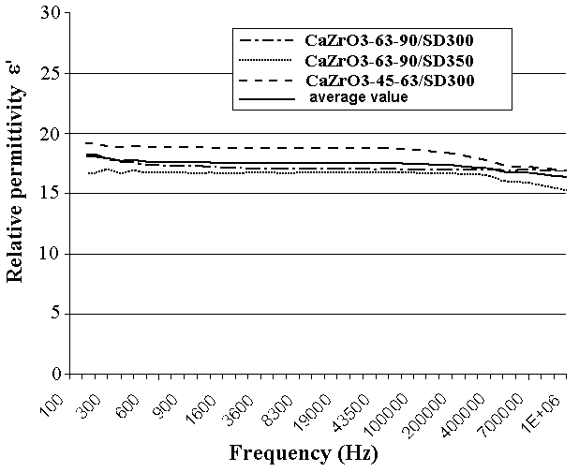
Relative permittivity results are shown in Fig. 1. Plasma deposits have slightly higher permittivity than reported in the literature [2]. This is probably due to inhomogeneous distribution of charge between lamellas with various Ca (or CaO) content. The permittivity differs only slightly with powder size and spray distance, and values are stable at changing frequency. One important feature of Class 1 dielectrics is stable capacitance with temperature changes. The sample 63-90, SD 300 shows good stability in the range 20 to 150°C for the whole studied frequency range. CaZrO₃ plasma deposits exhibit excellent resistivity 9.10¹¹ – 1.2x10¹³ Ωm, it is fully comparable with bulk Class 1 dielectric materials.
Figure 1. Relative permittivity versus frequency
for various states of plasma sprayed CaZrO₃

4. References
[1] R.A. Davies, M.S. Islam, A.V. Chadwick and G.E. Rush: Cation dopant sites in the CaZrO₃ proton conductor: A combined EXAFS and computer simulation study, Solid State Ionics 130 (2000)
[2] K. Neufuss et al: Structure and properties of CaZrO₃ coatings prepared by WSP and APS spraying, Proc. of Int. Thermal Spray Conf., 2003

